**Team Glossary**

**Arrival City—City of flight destination.**

**“Book” a Trip—this is another term used for reserving a flight and may also be used to describe the planning process for the trip.**

**Card Security Value (CSV) Number—This is the security number located on the back of most credit cards.**

**Cheapest Fare—This is an option the customer will choose as a personal preference**

**Cougar Path Travel—Name of the travel reservation company to whom we are developing the “Express Flights Locater” software package.**

**CRATD(Central Repository of Air Travel Data)—The database that contains specific airline information necessary to plan and analyze reservation costs.**

**Customer Number—This is the number assigned to the customer to keep the customer identified individually for accurate and quick look-up.**

**Customer Profile Information—a collection of basic information about the customer that will be maintained on the local database and is comprised of (customer's name, address, email address, phone number, Credit card information [holder’s name, card type, card number, expiration date, and Card Security Value (CSV) number] and a billing address)**

**Customer—People who are interested in planning a flight with Cougar Path Travel that are either potential or current within the system.**

**Daily Report—A daily task done by the manager that summarizes business that was conducted throughout the day. It is comprised of a financial and contact section.**

**Departure City—City of flight origin.**

**Discount—a reduction in price that is applied to the total price at any inconvenience to the customer**

**“EFL” Database—Local database containing local data such as airport codes, airlines, departure times, airline mileage, airport fees, etc…**

**Express Flights Locater—name of the software package we are developing for the client.**

**Final Destination—The arrival city of the last flight in a chain of flights.**

**Flight Status—An indicator that specifies if a flight is going to be delayed, cancelled or is on-time.**

**Flight Travel Data—Data pulled from the CRATD in a text format and updated within the data members of the Express Flights Locator.**

**In-person Service—Services being provided by an agent or a manger to a customer in a face-to-face setting.**

**Itinerary Case—These are individual cases that contain information about a current searches, reservations, and modification to a current flight and are instantiated every time a customer wants to search for a new flight search based around different search parameters or decides to cancel their current flight a whole new itinerary case opens.**

**Leg—generally refers to a single flight within a chain of flights but can mean a single flight.**

**Manager—Agent that has a higher level of access and additional tasks within the system**

**On-phone Service—Services being provided by an agent or a manager to a customer over a telephone connection.**

**“plan-to-go” Fee Structure—Flat fee that is charged for the service of assisting in finding the optimal flight for the customer regardless of if the customer actually books the trip or not.**

**Price “Watch” Threshold—The price specified by the customer in which they will be notified of specific flights based on their itinerary specifications.**

**Price “Watch”—A service offered by the client that monitors the price of a set of flights based on a set of criteria and waits for any flight to meet a price threshold based on the customers specification.**

**Shortest Number Of Flights— refers to the least number of connecting flights between the departure and arrival airport.**

**Shortest Time—refers to the shortest flight time from first departure until the last arrival at the traveler’s final destination.**

**Travel Agent—trained professionals that interact with and assist the customer in finding flights that meet the customer’s needs.**

**Travel Reservation Company—is a company that assists customers in finding and purchasing airfare at the most convenient and reasonable price based on the customer’s needs.**

**USE CASES**

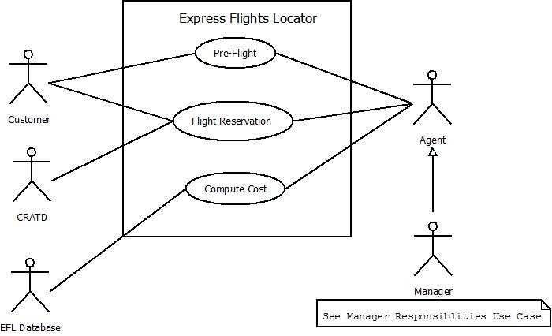

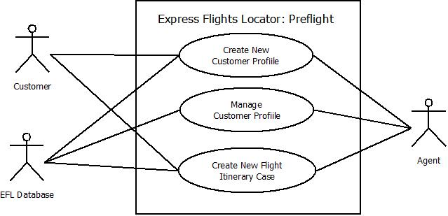

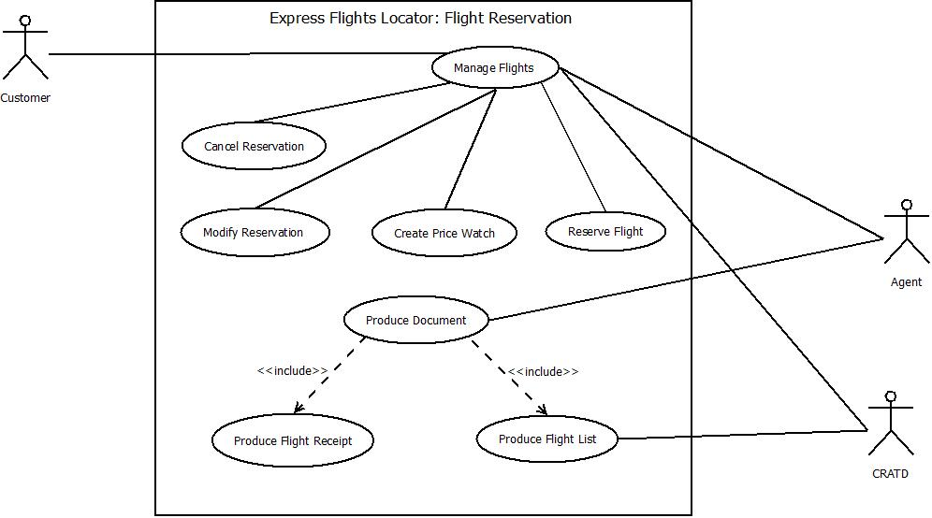

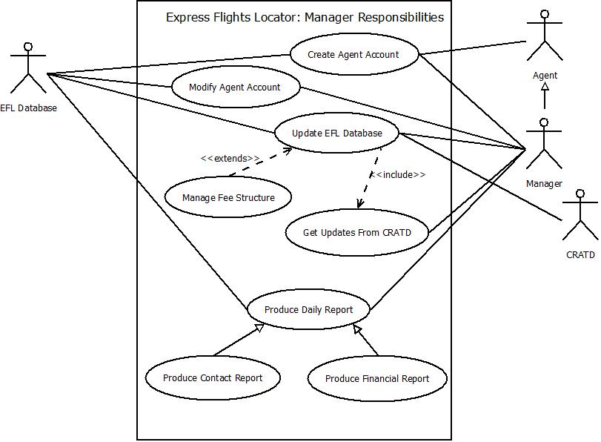

**Use Case Descriptions**

|  |  |
| --- | --- |
| **Use Case Name:** | Create New Customer Profile |
| Related Requirements |  |
| Goal in Context | Successfully create a customer profile |
| Preconditions | 1. Customer wants to book a flight (calls or comes to the agency in person)  2. Customer has:  A Name  An Address of Residency  A Phone Number |
| Successful End Condition | The new customer profile is created and stored |
| Failed End Condition | The customer profile is not successfully created or stored |
| Primary Actor(s) | Customer  Agent |
| Secondary Actor(s) |  |
| Trigger | Customer calls or enters Cougar Path Travel |

|  |  |  |
| --- | --- | --- |
| **Main Flow** | **Step** | **Action** |
|  | 1 | New Customer calls or enters Cougar Path Travel |
|  | 2 | Agent explains fee structure |
|  | 3 | Customer accepts or denies services |
|  | 4 | Agent collects customer information |
|  |  |  |
|  |  |  |
|  |  |  |
|  |  |  |
|  |  |  |
| **Extensions** | **Step** | **Branching Action** |
|  |  |  |
|  |  |  |
| **Use Case Name:** | Manage Existing Customer Profile | |
| Related Requirements |  | |
| Goal in Context | Lookup the Customer by:  Name  Phone Number  Manage Customer information | |
| Preconditions | Customer must have a valid profile in the system | |
| Successful End Condition | Agent successfully manages Customer’s profile by updating any changes in the Customer’s information and saving changes to the system | |
| Failed End Condition | Agent fails to manage Customer’s profile | |
| Primary Actor(s) | Customer  Agent | |
| Secondary Actor(s) |  | |
| Trigger | Existing Customer wants to make a flight reservation. | |
|  |  | |
|  |  | |
|  |  | |
|  |  | |
|  |  | |

|  |  |  |
| --- | --- | --- |
| **Main Flow** | **Step** | **Action** |
|  | 1 | Existing customer enters or calls the agency |
|  | 2 | Agent requests either name or phone number |
|  | 3 | Agent enters received name or phone number into GUI |
|  | 4 | Agent “searches” the existing pool of customer profiles |
|  | 5 | After finding the customer’s profile, the agent updates customer’s info. |
|  | 6 | Agent saves changes to the customer’s profile |
|  |  |  |
|  |  |  |
|  |  |  |
|  |  |  |
| **Extensions** | **Step** | **Branching Action** |
|  |  |  |
|  |  |  |
|  |  |  |
| **Use Case Name:** | Create New Itinerary Case | |
| Related Requirements |  | |
| Goal in Context | Successfully create a new itinerary case for a customer | |
| Preconditions | Customer has a customer profile stored in the system  Customer profile is opened Customer wants to reserve a flight | |
| Successful End Condition | Itinerary list is successfully created and provided to the customer | |
| Failed End Condition | Itinerary list creation is unsuccessful or fails | |
| Primary Actor(s) | Customer  Agent | |
| Secondary Actor(s) |  | |
| Trigger | Customer with a customer profile wishes to make a flight reservation. | |

|  |  |  |
| --- | --- | --- |
| **Main Flow** | **Step** | **Action** |
|  | 1 | Customer with a customer profile wishes to reserve a flight |
|  | 2 | Agent requests that the customer provide:  Departure City  Arrival City  Dates of Travel  Number of travelers (up to 5) |
|  | 3 | Agent asks customer if:  Cheapest Fare  Shortest Time  Shortest Number of Flights  Is preferred, explaining each |
|  | 4 | Agent enters data into computer |
|  | 5 | System returns sorted list of options based on customer preferences |
|  |  |  |
|  |  |  |
|  |  |  |
|  |  |  |
|  |  |  |
| **Extensions** | **Step** | **Branching Action** |
|  |  |  |
| **Use Case Name:** | Produce Flight List | |
| Related Requirements |  | |
| Goal in Context | Successfully produce the list | |
| Preconditions | A customer with an existing customer profile has requested to reserve a flight  Itinerary case was completed by customer supplying the following required information if it has been changed since their last reservation:  Whether cheapest far, shortest time, or shortest number of flights is preferred  The names of each traveler (up to 5)  Payment information (holder’s name, card type, card number, expiration date,  Card Security Value, and billing address. | |
| Successful End Condition | An agent has successfully accessed the local system and created the flight list for the customer’s convenience | |
| Failed End Condition | Flight list creation fails | |
| Primary Actor(s) | Customer  Agent  Local Flight Database | |
| Secondary Actor(s) |  | |
| Trigger | A customer has requested to make a flight reservation and has provided the necessary information to the agent to make such a reservation. The customer now requires a list of traveling options | |

|  |  |  |
| --- | --- | --- |
| **Main Flow** | **Step** | **Action** |
|  | 1 | Agent asks for traveling information and billing information |
|  | 2 | Customer provides traveling and billing information |
|  | 3 | Agent enters information into the system |
|  | 4 | System arranges a list based on the customer’s personal preferences |
|  | 5 | Agent receives the list and prints it, making it a physical document |
|  | 6 | Flight list is delivered to the customer |
|  | 7 | Itinerary case is completed and customer wishes to reserve a flight |
|  |  |  |
|  |  |  |
| **Extensions** | **Step** | **Branching Action** |
|  |  |  |
|  |  |  |
| **Use Case Name:** | Reserve Flights | |
| Related Requirements |  | |
| Goal in Context | Successfully reserve a flight for a customer | |
| Preconditions | Customer must have a customer profile  Customer must have provided valid information including traveling and billing information as well as one of the following personal preferences:  (cheapest fare, shortest time, shortest number of flights) | |
| Successful End Condition | Flight reservation is successfully made and record of it is stored in the CRATD system | |
| Failed End Condition | Flight reservation is not successfully made or reservation record is not stored in the system | |
| Primary Actor(s) | Customer  Agent  CRATD | |
| Secondary Actor(s) |  | |
| Trigger | Customer wishes to reserve a flight and meets all requirements to do so | |
| **Main Flow** | **Step** | **Action** |
|  | 1 | Customer begins the reservation process |
|  | 2 | Agent queries the customer about changes in customer profile information |
|  | 3 | Customer responds to querying with answer(s) |
|  | 4 | Agent puts customer’s information into the computer if need be |
|  | 5 | Agent sends information to the CRATD |
|  | 6 | CRATD stores information |
|  | 7 | Reservation of flight is complete |
| **Extensions** | **Step** | **Branching Action** |
|  | 3.A.1 | Customer specifies that there are no changes to their information |
|  | 3.A.2 | Continue to step 4 |
|  | 3.B.1 | Customer specifies that there are changes that will need to be made to their customer profile |
|  | 3.B.2 | Agent and Customer converse about what changes need to be made. |
|  | 3.B.3 | Agent makes all changes to the customer’s profile |
|  | 3.B.4 | Continue to step 4 |

|  |  |
| --- | --- |
| **Use Case Name:** | Modify Reservation |
| Related Requirements |  |
| Goal in Context | Successfully modify a flight reservation after a flight has been reserved by a customer |
| Preconditions | A customer has gone through all required steps leading up to and including reserving a flight. |
| Successful End Condition | Flight reservation has been successfully modified |
| Failed End Condition | Flight reservation has not been modified successfully |
| Primary Actor(s) | Customer  Agent  CRATD |
| Secondary Actor(s) |  |
| Trigger | Customer calls or enters the agency and requests to modify a flight reservation |

|  |  |  |
| --- | --- | --- |
| **Main Flow** | **Step** | **Action** |
|  | 1 | Customer requests to modify a flight reservation |
|  | 2 | Agent assists the customer in modifying the flight reservation |
|  | 3 | CRATD is updated with changed information |
|  |  |  |
|  |  |  |
|  |  |  |
|  |  |  |
|  |  |  |
|  |  |  |
|  |  |  |
| **Extensions** | **Step** | **Branching Action** |
|  |  |  |
|  |  |  |
|  |  |  |
|  |  |  |
| **Use Case Name:** | Cancel Reservation | |
| Related Requirements |  | |
| Goal in Context | Successfully cancel a flight reservation after a flight has been reserved by a customer | |
| Preconditions | A customer has gone through all required steps leading up to and including reserving a flight | |
| Successful End Condition | Flight reservation has been successfully canceled | |
| Failed End Condition | Flight reservation has not been cancelled successfully | |
| Primary Actor(s) | Customer  Agent  CRATD | |
| Secondary Actor(s) |  | |
| Trigger | Customer calls or enters the agency and requests to cancel a flight reservation | |

|  |  |  |
| --- | --- | --- |
| **Main Flow** | **Step** | **Action** |
|  | 1 | Customer requests to cancel a flight reservation |
|  | 2 | Agent assists the customer in canceling the flight reservation |
|  | 3 | CRATD is updated with changed information |
|  |  |  |
|  |  |  |
|  |  |  |
|  |  |  |
|  |  |  |
|  |  |  |
|  |  |  |
| **Extensions** | **Step** | **Branching Action** |
|  |  |  |
|  |  |  |
|  |  |  |
|  |  |  |
| **Use Case Name:** | Produce Flight Receipt | |
| Related Requirements |  | |
| Goal in Context | Print the flight receipt for the customer to refer to in the future. | |
| Preconditions | Customer has a profile in the system, has entered or called the agency requesting to reserve a flight, has looked over the personalized list of available options after providing traveling and billing information, and has come to a decision as to what services he/she will be paying for. | |
| Successful End Condition | Customer’s receipt is successfully printed and delivered to the customer. | |
| Failed End Condition | Customer’s receipt fails to be printed or delivered to the customer. | |
| Primary Actor(s) | Customer  Agent  EFL Database | |
| Secondary Actor(s) |  | |
| Trigger | Flight reservation is completed as well as customer decision based on their flight list | |
| **Main Flow** | **Step** | **Action** |
|  | 1 | Customer decides on a particular flight travel path/plan |
|  | 2 | Agent enters information into the computer, making use of our product |
|  | 3 | Local Flight Database (system) generates a receipt |
|  | 4 | Receipt is delivered to the customer |
|  |  |  |
|  |  |  |
|  |  |  |
|  |  |  |
|  |  |  |
|  |  |  |
| **Extensions** | **Step** | **Branching Action** |
|  |  |  |
|  |  |  |
|  |  |  |
| **Use Case Name:** | Create Price Watch | |
| Related Requirements | Reserve Flight | |
| Goal in Context | Create a price watch that will notify the customer if the price of a certain flight drops below a specific threshold | |
| Preconditions | The customer has a customer profile  The customer has asked to reserve a flight The customer has been made a flight list  The customer has decided to opt out of a flight due to the price | |
| Successful End Condition | A price watch is successfully created and will last 30 days or until the customer makes a reservation | |
| Failed End Condition | A price watch is not created | |
| Primary Actor(s) | Customer  Agent | |
| Secondary Actor(s) |  | |
| Trigger | Customer declines a reservation because of cost | |

|  |  |  |
| --- | --- | --- |
| **Main Flow** | **Step** | **Action** |
|  | 1 | Customer declines reservation because of cost |
|  | 2 | Agent informs customer about price watches |
|  | 3 | Agent asks customer if they would like to place a price watch on the flight |
|  | 4 | Customer replies |
|  | 5 | Agent creates a price watch on the flight the customer is interested in reserving |
|  | 6 | A price watch is successfully created |
|  | 7 | End of procedure |
|  |  |  |
|  |  |  |
| **Extensions** | **Step** | **Branching Action** |
|  | 4.A.1 | Customer replies that they would like a price watch |
|  | 4.A.2 | Go to Step 5 |
|  | 4.B.1 | Customer replies that they are not interested in creating a price watch |
|  | 4.B.2 | Go to Step 7 |
| **Use Case Name:** | Create Agent Account | |
| Related Requirements |  | |
| Goal in Context | Successfully create an agent account | |
| Preconditions | 1. Agent is currently employed at Cougar Path Travel  2. Agent has:  A Name  An Address of Residency  A Phone Number  An ID Number  A Password used to log onto the system | |
| Successful End Condition | The new agent account is created and stored | |
| Failed End Condition | The agent account is not successfully created or stored | |
| Primary Actor(s) | Manager  Agent  EFL Database | |
| Secondary Actor(s) |  | |
| Trigger | Agent is hired at Cougar Path Travel | |
| **Main Flow** | **Step** | **Action** |
|  | 1 | New agent is hired |
|  | 2 | Agent is trained by manager |
|  | 3 | Manager queries agent for required information |
|  | 4 | Agent provides information |
|  | 5 | Manager puts information into computer |
|  | 6 | Manager saves new agent account to EFL database, finishing the creation of a new agent account |
|  |  |  |
|  |  |  |
|  |  |  |
|  |  |  |
| **Extensions** | **Step** | **Branching Action** |
|  | 5.1 | Manager puts agent’s personal information into the system |
|  | 5.2 | Manager creates a unique ID number and system log in password for the new agent |
|  | 5.3 | Go to Step 6 |
|  |  |  |

|  |  |
| --- | --- |
| **Use Case Name:** | Modify Agent Account |
| Related Requirements |  |
| Goal in Context | Manage an agent’s account by saving modifications of the agent’s personal information to the EFL |
| Preconditions | Agent must have a valid account in the EFL database |
| Successful End Condition | Manager successfully manages agent’s profile by updating any changes in personal information and saving changes to the system |
| Failed End Condition | Manager fails to manage agent’s account by successfully updating it with changes |
| Primary Actor(s) | Manager  Agent  EFL Database |
| Secondary Actor(s) |  |
| Trigger | Agent with an account requests to change personal information |

|  |  |  |
| --- | --- | --- |
| **Main Flow** | **Step** | **Action** |
|  | 1 | Existing agent requests to have information changed in their account |
|  | 2 | Manager inquires what information should be changed |
|  | 3 | Agent responds with personal information to change |
|  | 4 | Manager inputs data to change in the system |
|  | 5 | Manager saves changes to the agent’s profile, updating the EFL database |
|  |  |  |
|  |  |  |
|  |  |  |
|  |  |  |
|  |  |  |
| **Extensions** | **Step** | **Branching Action** |
|  |  |  |
| **Use Case Name:** | Produce Daily Report | |
| Related Requirements | Produce Financial Report  Produce Contact Report | |
| Goal in Context | Successfully produce a daily report (financial or contact) | |
| Preconditions | It is the end of the work day | |
| Successful End Condition | Manager successfully creates a particular type of daily report (Financial or Contact) | |
| Failed End Condition | Manager fails to create the daily report | |
| Primary Actor(s) | Manager  EFL Database | |
| Secondary Actor(s) |  | |
| Trigger | At the end of the day, a manager fulfilling his or her roles is required to run a daily report. | |

|  |  |  |
| --- | --- | --- |
| **Main Flow** | **Step** | **Action** |
|  | 1 | Manager decides to start working on a daily report |
|  | 2 | Manager works on daily report |
|  | 3 | Manager finishes daily report |
|  |  |  |
|  |  |  |
|  |  |  |
| **Extensions** | **Step** | **Branching Action** |
|  | 2.A.1 | Start financial section of the daily report |
|  | 2.A.2 | Finish financial section of the daily report |
|  | 2.A.3 | Go to Step 3 (Financial Report Complete) |
|  | 2.B.1 | Start contact section of the daily report |
|  | 2.B.2 | Finish contact section of the daily report |
|  | 2.B.3 | Go to Step 3 (Contact Report Complete) |
|  |  |  |
| **Use Case Name:** | Get Updates From The CRATD | |
| Related Requirements | Update EFL Database | |
| Goal in Context | Download any updates from the CRATD if they are available | |
| Preconditions | The manager has access to the CRATD | |
| Successful End Condition | Updates are downloaded by the manager | |
| Failed End Condition | The manager fails to download updates from the CRATD | |
| Primary Actor(s) | Manager  CRATD | |
| Secondary Actor(s) |  | |
| Trigger | Managers must download updates from the CRATD nightly. It is night time and the manager wishes to fulfill his or her duty. | |

|  |  |  |
| --- | --- | --- |
| **Main Flow** | **Step** | **Action** |
|  | 1 | Manager checks CRATD for available updates |
|  | 2 | Manager downloads updates |
|  | 3 | Procedure complete |
|  |  |  |
|  |  |  |
|  |  |  |
|  |  |  |
|  |  |  |
| **Extensions** | **Step** | **Branching Action** |
|  | 2.A.1 | Available updates exist and are downloaded |
|  | 2.A.2 | Go to Step 3 reporting Success |
|  | 2.B.1 | No updates are available from the CRATD. |
|  | 2.B.2 | Go to Step 3 reporting Fail |
|  |  |  |
| **Use Case Name:** | Compute Cost | |
| Related Requirements |  | |
| Goal in Context | Perform all calculations required to compute the cost of a trip | |
| Preconditions | A customer must have successfully reserved a flight  Any updates from the CRATD must have been successfully made An agent has an existing account | |
| Successful End Condition | The cost has been successfully computed and a customer’s account credit balance is successfully updated | |
| Failed End Condition | An agent fails to compute the cost or update a customer’s account credit balance is not updated. | |
| Primary Actor(s) | Agent  EFL Database | |
| Secondary Actor(s) |  | |
| Trigger | After a flight reservation is created, a cost will be computed | |

|  |  |  |
| --- | --- | --- |
| **Main Flow** | **Step** | **Action** |
|  | 1 | An agent begins the compute cost procedure |
|  | 2 | The cost per mile per airline fee is computed |
|  | 3 | The airport fee is computed by summing airport service fees |
|  | 4 | The agency’s fee is computed |
|  | 5 | Customer’s credit balance is updated |
|  | 6 | The total cost is calculated |
| **Extensions** | **Step** | **Branching Action** |
|  | 2.A.1 | The trip is either not a multi-leg trip, or does not contain subsequent legs chartered by the same airline  So, we do not have to calculate any cost discounts |
|  | 2.A.2 | The cost per mile per airline fee is equal to the sum of the products of each leg’s cost per mile rate and the distance traveled |
|  | 2.B.1 | The trip is a multi-leg trip in which subsequent legs are chartered by the same airline |
|  | 2.B.2 | Compute the adjusted cost per mile per airline fee by factoring in any discounts |
|  | 4.A.1 | If the customer has not made a flight reservation at the agency before, the standard “plan-to-go” fee is added to the total cost |
|  | 4.B.1 | If the customer has made a flight reservation at the agency before, an adjusted “plan-to-go” fee is added to the total cost |
|  | 4.B.2 | If the customer has made between 2 and 9 reservations inclusive, $5 will be taken off the fee, If the customer has made > 10 reservations, $10 will be deducted |